SavePoint(I)

Within a transaction, if we want to rollback a particular group of operations based on some condition then we need to use savepoint

a. getting savepoint using the following method

Savepoint sp = connection.setSavePoint();

b. To perform rollback operation for a particular group of operations w.r.t savepoint then we need to use rollback.

connection.rollback(sp);

c. we can release the savepoint or delete the savepoint as shown below

connection.releaseSavePoint(sp);

Case study

=====================================

connection.setAutocommit(false);

operation-1

operation-2

operation-3

SavePoint sp = connection.setSavePoint();

operation-4

operation-5

if(balance<1000)

connection.rollback(sp);

else

connection.releaseSavepoint(sp);

connection.commit();

if balance< 1000 then operation 4,5 will be rollbacked, otherwise all the operations will be committed.

eg:

connection.setAutocommit(false);

st.executeUpdate("insert into politicians values('BJP', 'Modi'));

st.executeUpdate("insert into politicians values('TRS','KCR')");

SavePoint sp = connection.setSavePoint();

st.executeUpdate("insert into politicians values('BJP','siddu')");

connection.rollback(sp);

..

...

connection.releaseSavePoint(sp);

..

connection.commit();

Eg: Jdbc_Transaction_Savepoint_Rollback

Types of ResultSet:

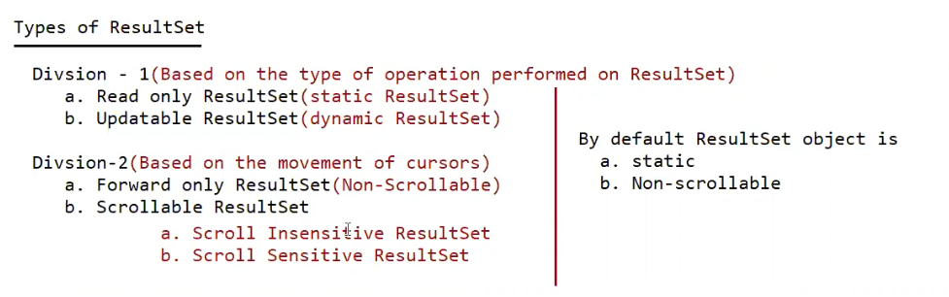

SQL> create table scrollableapp ( id int , name nvarchar2(15) , age int , address nvarchar2(15));

SQL> insert into scrollableapp values ( 1 , 'pavan' , 24 , 'vijayawada');

SQL> insert into scrollableapp values ( 2 , 'anand' , 23 , 'vijayawada');

SQL> insert into scrollableapp values ( 3 , 'pavankumar' , 24 , 'vijayawada');

SQL> insert into scrollableapp values ( 4 , 'charan' , 23 , 'ongole');

SQL> insert into scrollableapp values ( 5 , 'tarun' , 24 , 'vijayawada');

SQL> insert into scrollableapp values ( 6 , 'mpavan' , 24 , 'vijayawada');

SQL> insert into scrollableapp values ( 7 , 'ppavan' , 24 , 'vijayawada');

SQL> insert into scrollableapp values ( 8 , 'teja' , 24 , 'vijayawada');

absolute() -> it works from the BFR or from ALR.

relative() -> it works w.r.t current position.

In both the methods positive means move in forward direction, negative means move in backward direction.

Note:

rs.last() and rs.absolute(-1) both are equal

rs.first() and rs.absolute(1) both are equal